Вводный урок 13+ после сокращения
Как читать. Каждая тема чек-листа проверяется 1–2 раза. «Назвать предмет» даёт балл, только если слово само из темы (мяч → Sports; паспорт к теме Countries не относится — её проверяют флаг и вопрос). Сортировка и «соедини пары» — одно задание: по теме считается раз. Верный вариант — зелёный, на экране варианты перемешаны. Справа серым — тема чек-листа. На экране ученика — только короткая инструкция по-английски; русский заголовок задания — для учителя, он в плане.
Начало урока: Welcome to WowSpeak School! → знакомство, три вопроса по одной карточке (What’s your name? How old are you? What do you like doing in your free time?) → учитель рассказывает историю квеста → комната 1.

Часть 1 · Гостиная (уровень A1.1–A1.2)

1. Семейная фотография
Назвать: What's this? → a family photo без балла
Задание 1. Семья Тома на экране: Look and choose.
[картинка: семейное дерево — соберу из портретов, покажу превью]
1) Bob is Emma’s ___ . — uncle / father / grandfather Families
2) Mark and Kate ___ Tom’s parents. — are / is / am To be
Картинка — новое семейное дерево схемой: George ═ Rose → их сыновья Mark и Bob; Mark ═ Kate → Tom и Emma; Bob ═ Lily. Под портретами только имена.
And you? Tell me about your family. Families, To be
→ кусочек записки

2. Рюкзак
Назвать: What's this? → a schoolbag (a backpack) School objects
Задание 1. Что в рюкзаке у Тома на экране: Look and choose.
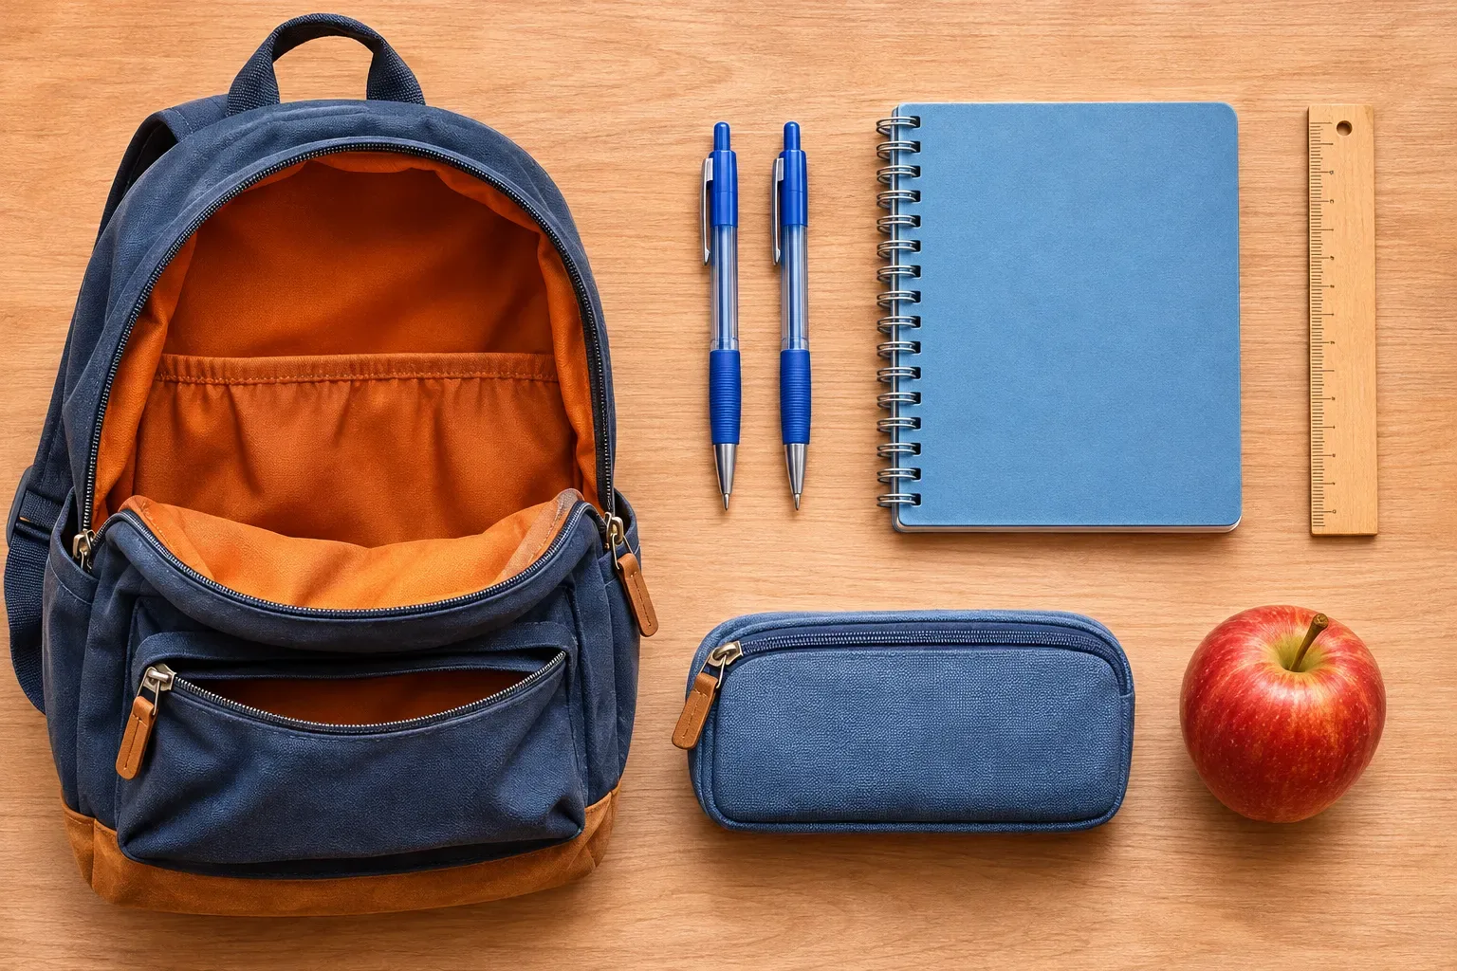
1) There ___ two pens. — are / is / am There is
2) Tom ___ got a pencil case. — has / have / is Have got
And you? What have you got in your school bag? School objects, Have got
→ кусочек записки

3. Паспорт
Назвать: What's this? → a passport без балла
Задание 1. Паспорт друга Тома на экране: Look at the flag and choose.
1) 🇩🇪 Hans is from Germany. He’s ___ . — German / Germany / Germanish Countries
And you? Where are you from? Which country would you like to visit? Countries
→ кусочек записки

4. Ваза с фруктами
Назвать: What's this? → fruit (a bowl of fruit) Food and drinks
Задание 1. Что в холодильнике у Тома на экране: Look and choose.
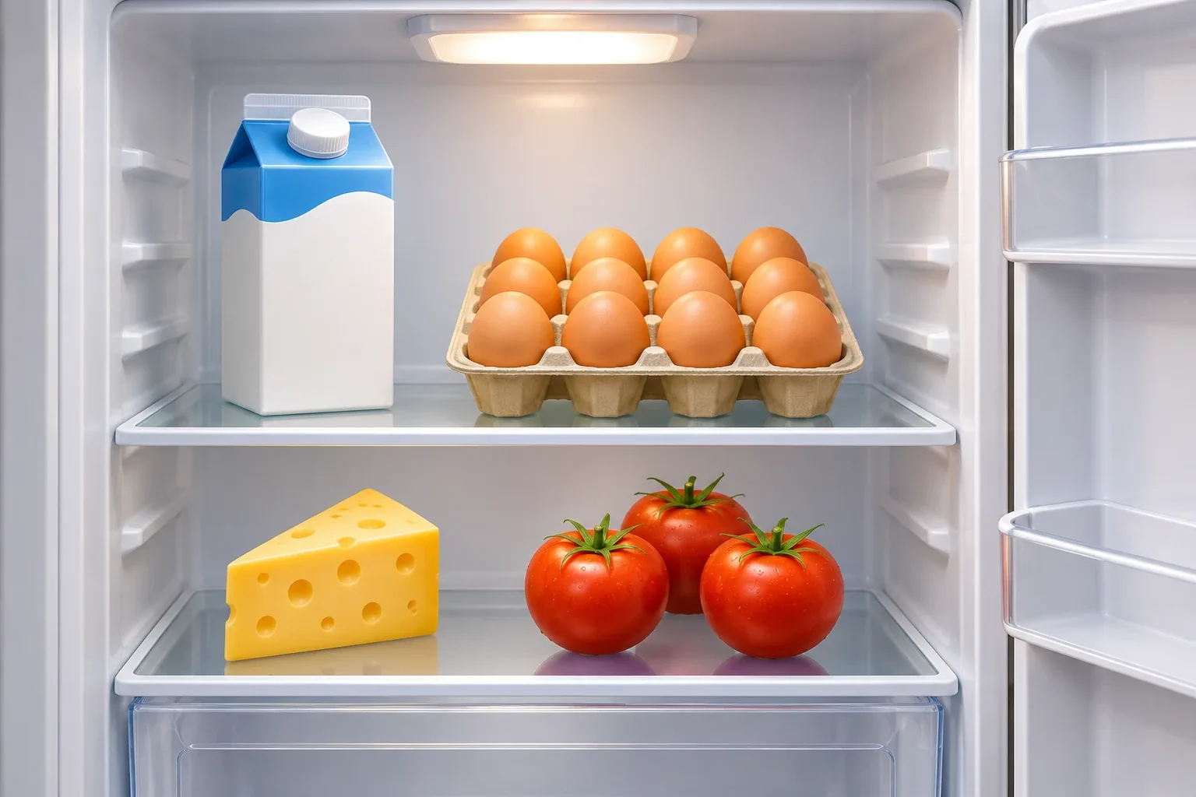
1) There is ___ milk in the fridge. — some / any / a Some, any, lots of
2) There aren’t ___ apples in the fridge. — any / some / a Some, any, lots of
Было «верно / неверно» на 6 пунктов — ответ был виден по картинке без грамматики.
And you? What do you usually have for breakfast? Food and drinks
→ кусочек записки

5. Футбольный мяч
Назвать: What's this? → a football (a ball) Sports
Задание 1. Том играет в футбол на экране: Look and choose one word.
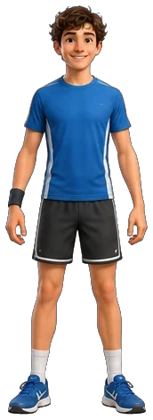
1) стрелка на колено — knee / foot / leg / arm Body parts
2) стрелка на ступню — foot / knee / leg / arm Body parts
Было пять стрелок, стало две.
Задание 2. Какой спорт любит Том на экране: Look and choose.
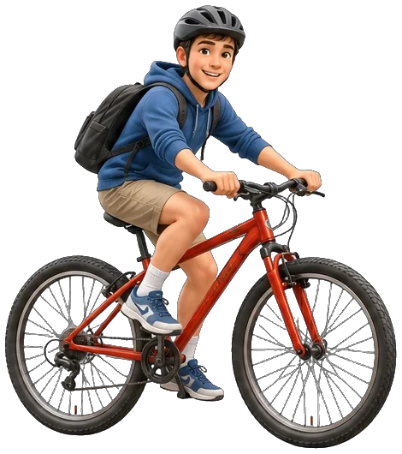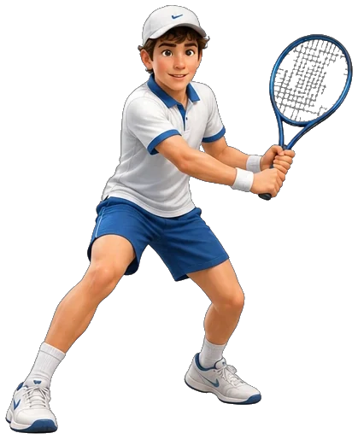
1) ___ Tom ride a bike to school? — Yes, he does. — Does / Do / Is Present Simple
2) Tom can play tennis, but he ___ play basketball. — can’t / can / don’t can Can/Can’t
Теннисную ракетку перерезать (замечание 13).
→ кусочек записки

6. Игрушечный автобус
Назвать: What's this? → a bus Transport
Задание 1. Вид из окна — устно на экране: Who can you see? What do they do? What is she doing? What’s on the bridge?
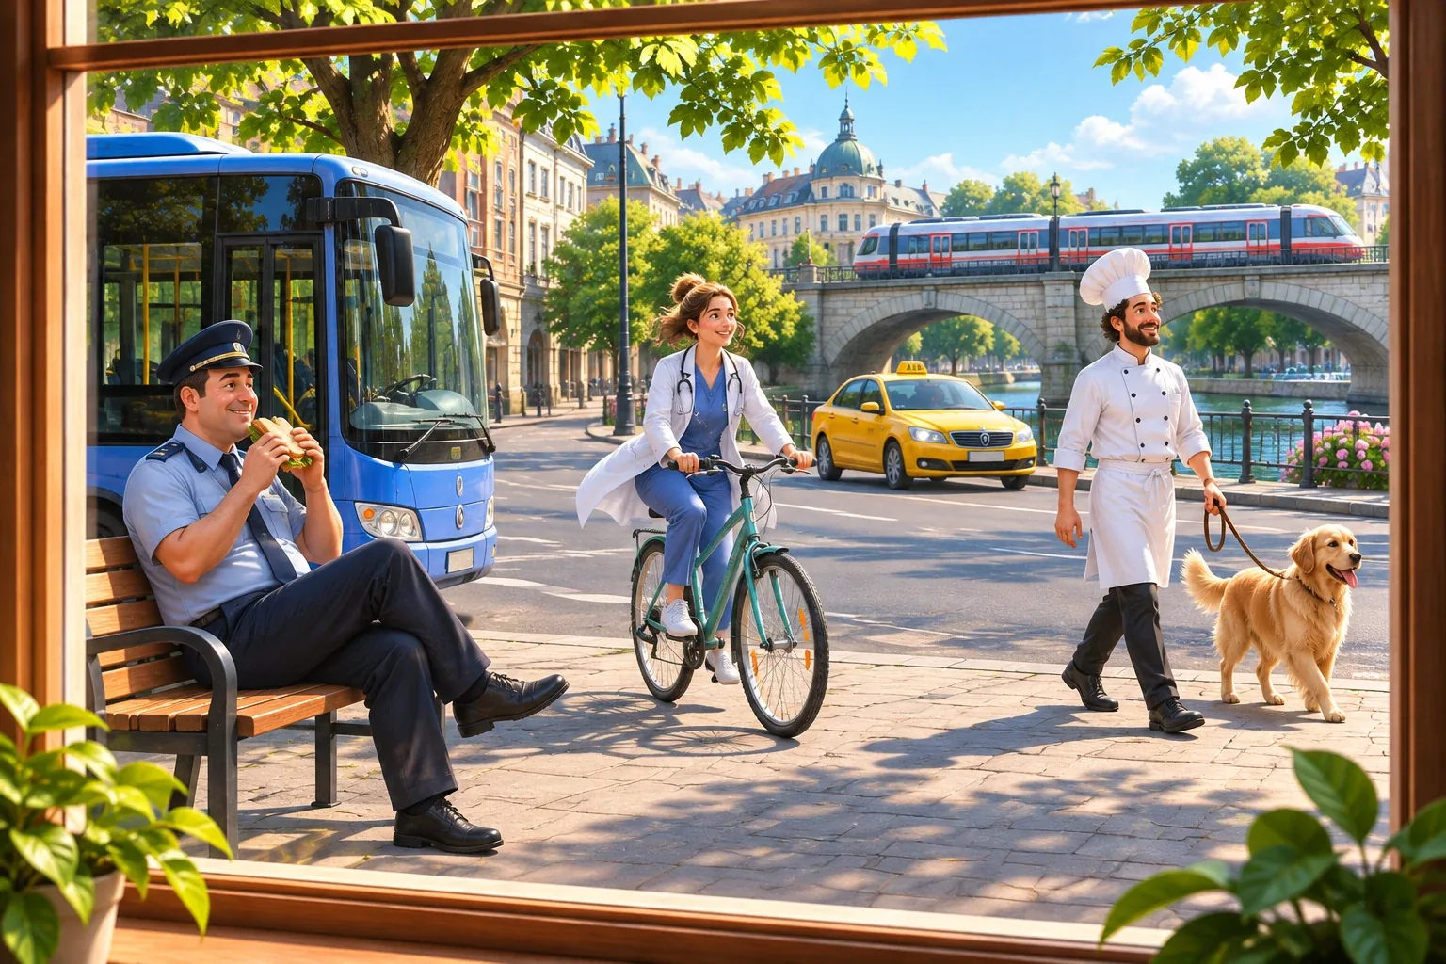
1) Ученик называет людей и профессии: a police officer, a doctor, a chef… Jobs (учитель ставит балл)
Вариантов нет — учитель спрашивает и отмечает, сколько профессий назвал ученик.

7. Билеты в кино
Назвать: What are these? → cinema tickets Entertainment
Задание 1. Собери предложение на экране: Put the words in order.
1) I always go to the cinema on Fridays. Adverbs of frequency
Задание 2. Выбери ответ на экране: Choose the right answer.
1) Let’s ___ to the cinema tonight! — go / going / to go Let’s…
And you? How often do you go to the cinema? What are your favourite places in your city? Adverbs of frequency, Entertainment
→ кусочек записки

8. Зонтик
Назвать: What's this? → an umbrella без балла
Задание 2. Едем на море: солнечно и жарко на экране: What do you take? Sort.
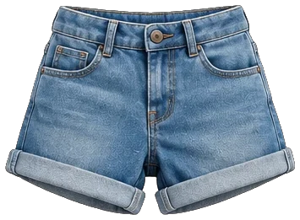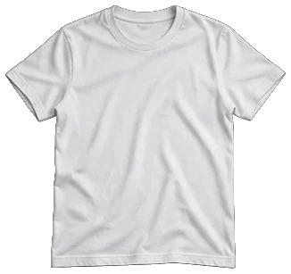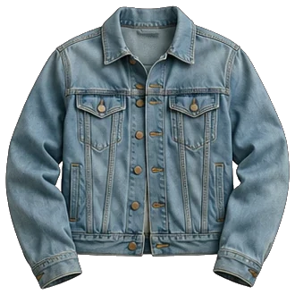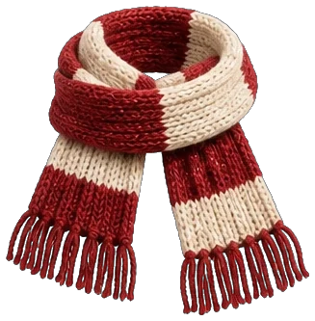
1) Take ✅: shorts, a T-shirt · Don’t take ❌: a jacket, a scarf Clothes
Четыре картинки без подписей. Ученик раскладывает и называет каждую вещь вслух (в плане). Картинки футболки и куртки готовы.
Задание 3. Выбери слово на экране: Choose the right word.
1) Tom ___ to the beach every summer. — goes / go / gos Present Simple
And you? What’s the weather like today? What do you need for a trip to the mountains? Weather, Need, want, Clothes
→ кусочек записки

9. Кошка
Назвать: What's this? → a cat Pets and farm animals
Задание 1. Животные на экране: Look and choose.
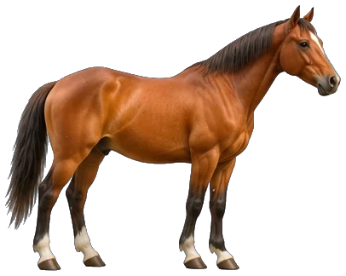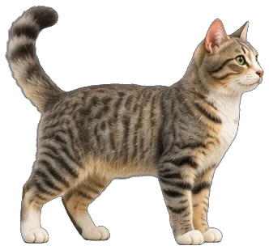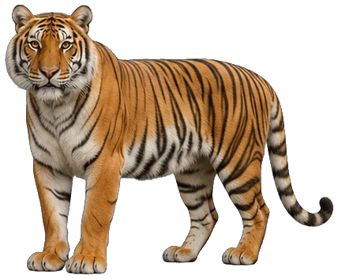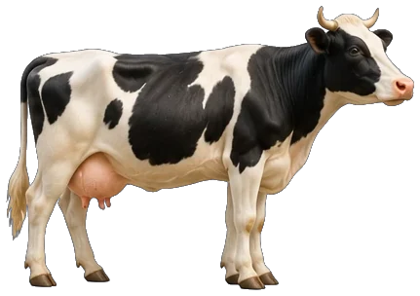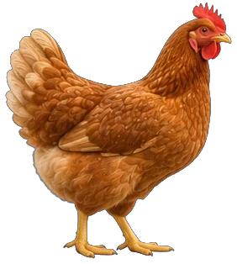
1) (лошадь и кошка) A horse is ___ than a cat. — bigger / big / biggest Comparatives
2) (тигр и кошка) A tiger is ___ than a cat. — more dangerous / dangerouser / most dangerous Comparatives
3) (корова, свинья, курица) Which animal gives us milk? — a cow / a pig / a chicken Pets and farm animals
Вёрстку переделать: картинки животных крупно (замечание 20). Тигр готов.
Задание 2. Голосовое сообщение на экране: Listen and choose.
1) What did Tom ride? — a horse / a bike / a bus Past Simple
2) Did he see the pigs? — No, he didn’t. / Yes, he did. / No, he don’t. Past Simple
3) What did they do in the evening? — They watched a film. / They played football. / They went to bed. Past Simple
Все три вопроса сразу на одном экране.
Текст записи: This is Tom. Yesterday he went to his grandparents’ farm. In the morning he fed the chickens and the sheep. Then he rode a horse! He didn’t see the pigs, because they were asleep. In the evening they had a big dinner and watched a film. It was a great day!
And you? What did you do last weekend? Past Simple
→ кусочек записки
Записка собрана → код (4 цифры). Экран с кодом: «Open the lock» — закончить урок, «Keep looking» — следующая часть.

Часть 2 · Тайный кабинет (уровень A2.1–B1.1)

1. Шкаф
Назвать: What's this? Describe it. → a big wooden wardrobe Household and furniture, Adjectives to describe objects
Задание 1. Спальня или кухня на экране: Sort the pictures. Name them.
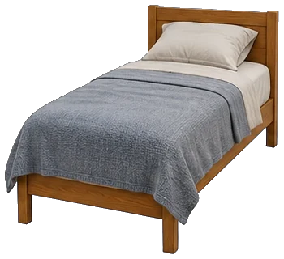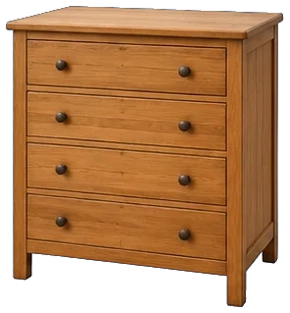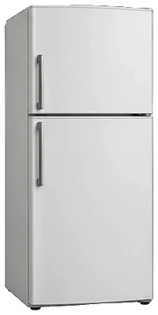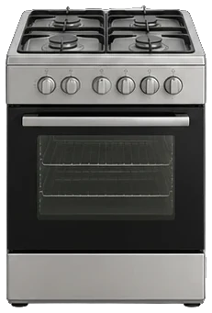
1) Bedroom: a bed, a chest of drawers · Kitchen: a fridge, a cooker Household and furniture
Четыре картинки без подписей: ученик раскладывает и называет каждую вещь. Одежду здесь не проверяем — она была в части 1.
Задание 2. Загляни в шкаф на экране: Choose the right word.
1) There aren’t ___ clothes in the wardrobe. — many / much / a Quantifiers
2) My sister keeps ___ shoes in this wardrobe — more than fifty pairs! — a lot of / much / any Quantifiers
And you? Describe your room. Adjectives to describe objects
→ кусочек записки

2. Чемодан
Назвать: What's this? → a suitcase Holidays
Задание 1. Как себя чувствовала Mia на экране: Look. How did Mia feel?

1) At the castle she was ___ . — excited / bored / angry Emotions
And you? Tell me about your best trip. Where did you go? How did you feel? Holidays, Past Simple, Emotions
→ кусочек записки

3. Карта
Назвать: What's this? → a map Geographical features
Задание 1. Соедини слова с картинками на экране: Match the words and the pictures.
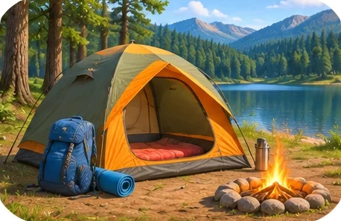
1) a river · an island · go sightseeing · go camping Geographical features, Travelling activities
Задание 2. Путешествие на экране: Choose the right answer.

1) We crossed the sea ___ . — by ferry / on foot / by bike Ways of travelling
2) Next summer we ___ climb these mountains. We’ve already bought the tickets. — are going to / might / will can Going to
3) I’m not sure, but I ___ go to Italy next year. — might / am going to / must Future with will, may, might
And you? What are you going to do this summer? Going to
→ кусочек записки

4. Аптечка
Назвать: What's this? → a first-aid kit Health and Illnesses
Задание 1. У врача на экране: Choose the right answer.
1) — What’s the matter? — I’ve got a ___ . I ate too much. — stomachache / stomach / hurt Health and Illnesses
3) You ___ stay in bed for two days. — must / mustn’t / don’t have to Must, have to – тут не хватает контекста, что это не don’t have to – может «не вставай, ты должен лежать. Или ты должен что-то другое делать, потому что …
4) It’s Saturday tomorrow — you ___ go to school. — don’t have to / have to / mustn’t to Have to / don’t have to
→ кусочек записки

5. Книга
Назвать: What's this? → a book (a novel) Free time activities: books and films
Задание 1. Отзыв о книге на экране: Choose the right answer.
1) This book ___ by a 15-year-old girl in 2010. — was written / wrote / is writing Passive
2) I love it! I ___ it three times. — have read / am reading / reads Present Perfect
3) Kate and Sam are best friends, but then they ___ in love. — fall / get / make Relationships
4) If you like adventures, you ___ love it. — will / would / are 1st Conditional
→ кусочек записки

6. Плакат «Разыскивается»
Назвать: What's this? → a poster (a wanted poster) Crime and criminals
Задание 2. Что было в музее на экране: Choose the right answer.
1) The thief ___ the painting when the alarm ___ . — was taking … rang / took … was ringing / was taking … was ringing Past Continuous vs Past Simple
Один вопрос с двумя пропусками.
And you? Describe someone in your family. What does he or she look like? Describing people
→ кусочек записки

7. Кошелёк
Назвать: What's this? → a wallet Money and shopping
Задание 1. Покупки на экране: Choose the right answer.
1) I ___ any new clothes for two years. — haven’t bought / didn’t buy / don’t buy Present Perfect vs Past Simple
2) I ___ my friends at the shopping centre at 5 tomorrow — it’s all arranged. — am meeting / meet / met Going to vs Present Continuous for future
→ кусочек записки

8. Ноутбук
Назвать: What's this? → a laptop Computer phrases
Задание 1. Переписка в чате: найди и исправь ошибку на экране: Find the mistake and correct it.
1) Tom said that he is tired. → ошибка is, верно: was Reported speech
2) The boy which lives next door is my friend. → ошибка which, верно: who Relative clauses
В каждом предложении есть ошибка. Ученик нажимает на неверное слово (балл ставится сам) и говорит правильный вариант вслух.
And you? What do you usually do on your phone? Computer phrases
→ кусочек записки

9. Бинокль
Назвать: What are these? → binoculars без балла
Задание 1. Еда в кафе напротив на экране: Match the words and the pictures.
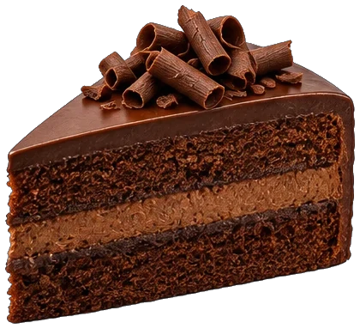
1) spicy · sour · sweet · salty Food and drink adjectives
Задание 2. Выбери слово на экране: Choose the right word.
1) ___ at that bird! It’s huge! — Look / See / Watch Look, see, watch
2) If I had better binoculars, I ___ see the birds on that island. — would / will / am 2nd Conditional
→ кусочек записки
Записка собрана → код (2 цифры). Экран с кодом: «Open the lock» — закончить урок, «Keep looking» — следующая часть.

Часть 3 · Тайная лаборатория (уровень B1.2–B2.2)

1. Кубок
Назвать: What's this? What is it for? → a trophy Sport phrases
Задание 1. Наша команда на экране: Choose the best answer.
1) Would you like to ___ our tennis club? — join / enter / win Sport phrases
2) ___ is my favourite sport — I won this trophy last year. — Swimming / Swim / To swimming Ing forms
3) I’m really good at ___ penalties. — scoring / score / to score Ing forms
4) Nick ___ like snowboarding, but now he loves it. — didn’t use to / doesn’t used to / not used to Used to
→ кусочек записки

2. Стетоскоп
Назвать: What's this? → a stethoscope без балла
Задание 1. У врача на экране: Choose the best answer.
1) I fell down the stairs and ___ my ankle. — sprained / coughed / sneezed Health verbs
2) You ___ go to bed earlier. You look really tired. — should / must to / have Modals of obligation and advice
And you? What should people do to stay healthy? What do you do? Modals of obligation and advice, Health verbs
→ кусочек записки

3. Микрофон
Назвать: What's this? What is it for? → a microphone без балла
And you? What kind of music do you listen to? Have you ever been to a concert? Music
→ кусочек записки

4. Смартфон
Назвать: What's this? What is it for? → a smartphone Social media
Задание 1. Голосовое сообщение на экране: Listen and choose.
1) What had Anna done before she suggested recording a video? — She had posted a photo online. / She had recorded a video. / She had met Jess at school. Past Perfect
2) What did Anna suggest? — recording a video together / going to the cinema / taking more photos Reporting verbs
3) Jess ___ Emma that Anna could be a great photographer. — told / said / spoke Verbs of communication
Все три вопроса сразу на одном экране.
Текст записи: Emma and Jess are best friends. Yesterday Emma saw a photo that Anna had posted online. Anna had taken it at sunset, and it was amazing. Jess had already seen it and had left a comment under it. She told Emma that Anna could be a great photographer. When Anna read the comments, she laughed and suggested recording a video together. Jess agreed, and they decided to meet on Sunday, because Jess doesn’t like putting things off.
Задание 2. Телефон Анны на экране: Choose the right answer.
1) Anna’s phone screen was broken, so ___ yesterday. — she had it repaired / she had repaired it / she have it repair Causative have→ кусочек записки

5. Шапочка выпускника
Назвать: What's this? What is it for? → a graduation cap Education
Задание 1. Школа и университет на экране: Choose the right answer.
1) Do you know where the exam room ___ ? — is / is it / does Question forms (complex)
2) Our school is believed ___ more than 200 years ago. — to have been built / to build / building Passive: complex forms
3) I get ___ really well with my classmates. — on / up / off Phrasal verbs for relationships
And you? Do you know what you would like to study in the future? Why? Education, Question forms (complex)
→ кусочек записки

6. Сейсмограф
Назвать: What's this? What is it for? → a seismograph Natural disasters
Задание 1. Соедини слова с картинками на экране: Match the words and the pictures.
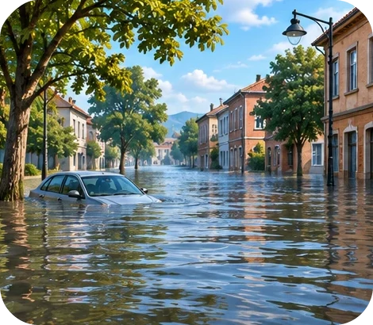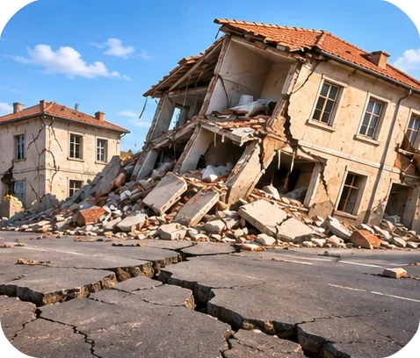
1) a volcanic eruption · a flood · an earthquake Natural disasters
Задание 2. Выбери ответ на экране: Choose the right answer.
1) When the volcano erupted, most people ___ escape in time. — were able to / could to / can Modals of ability and possibility
And you? What could you do to stay safe in an earthquake? Modals of ability and possibility
→ кусочек записки

7. Лупа
Назвать: What's this? What is it for? → a magnifying glass Crime and criminals
Задание 1. Место кражи на экране: Look and choose.

1) The broken glass is inside the room. The thief ___ through the window. — must have come / can’t have come / must come Modals of deduction in the past
2) “Where were you last night?” → The detective asked me where I ___ the night before. — had been / have been / was being Reported questions
3) “I didn’t take the money!” → The suspect ___ taking the money. — denied / admitted / suggested Reporting verbs
4) If the window had been locked, the thief ___ in. — wouldn’t have got / won’t get / didn’t get 3rd conditional
5) The owner always tells the truth. She is very ___ . — honest / selfish / lazy Personal qualities
6) A person who breaks into a house and steals things is a ___ . — burglar / witness / judge Crime and criminals
→ кусочек записки

8. Свиток
Назвать: What's this? What is it for? → a scroll History
Задание 2. История свитка на экране: Choose the right answer.
1) An old man ___ along the beach when he found an ancient scroll. — was walking / walked / has walked Narrative tenses
2) When I was little, my grandfather ___ tell me stories about our ancestors. — would / will / was Present and past habits
And you? What did your grandparents use to do when they were young? Present and past habits
→ кусочек записки

9. Капсула времени
Назвать: What's this? What is it for? → a time capsule Hopes and dreams
Задание 1. Будущее на экране: Look and choose.

1) This time next week Mia ___ to London. — will be flying / will have flown / flies Future Continuous
2) By the end of the year they ___ from university. — will have graduated / will be graduate / graduated Future Perfect
→ кусочек записки

10. Рекламный щит
Назвать: What's this? What is it for? → a billboard Advertising
Задание 1. Разложи слова на экране: Sort the words.
Задание 2. Слоганы: собери половинки на экране: Match the halves.
1) This new phone is great, but it costs … an arm and a leg. Idioms
2) Our new board game will help you break … the ice at any party! Idioms
3) The company could have chosen … a better slogan for this advert. Modals in the past
4) If I hadn’t seen that advert, … I wouldn’t be wearing these trainers now. 3rd and mixed conditionals
Задание 3. Артикли на экране: Choose a, an, the or —.
1) This is ___ best advert of the year! — the / a / — Determiners
2) It’s ___ advert for a new electric car. — an / a / the Determiners
And you? Have you ever bought something because of an advert? If you hadn’t seen it, would you have bought it? 3rd and mixed conditionals
→ кусочек записки
Записка собрана → код (2 цифры). Ученик читает код вслух → дверь открыта, финал.

